**AWS Snow family:-**

* To migrate the data on AWS environment
* To transfer the large amount of physical data to AWS

There are main 3 Types for moving the data to AWS:-

1. AWS snowball :-

AWS Snowball is a service that provides secure, rugged devices, so you can bring AWS computing and storage capabilities to your edge environments, and transfer data into and out of AWS

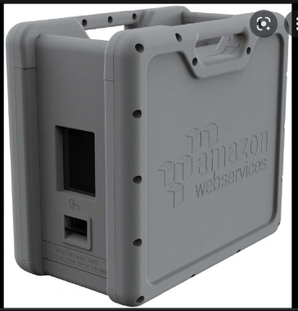

Capacity - It provides **up to 80 TB of usable HDD storage, 40 vCPUs, 1 TB of SATA SSD storage, and up to 40 Gb network connectivity** to address large scale data transfer and pre-processing use cases.

1. AWS Snowball Edge :-

AWS Snowball is a service that provides secure, rugged devices, so you can bring AWS computing and storage capabilities to your edge environments, and transfer data into and out of AWS.

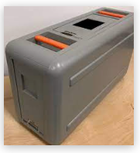

Capacity - Snowball Edge Storage Optimized **provides 80 TB of HDD capacity for block volumes and Amazon S3-compatible object storage,** and 1 TB of SATA SSD for block volumes.

1. AWS Snowmobile :-

AWS Snowmobile is an Exabyte-scale data transfer service used to move extremely large amounts of data to AWS. You can transfer up to 100PB per Snowmobile, a 45-foot long ruggedized shipping container, pulled by a semi-trailer truck.

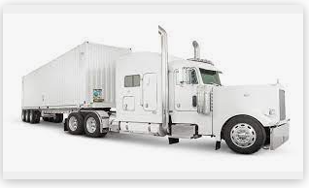

Capacity - Each Snowmobile has a total capacity of **up to 100 petabytes and multiple Snowmobiles** can be used in parallel to transfer exabytes of data.

**For AZUR:-**

1. Azure data box disk (Capacity- 8TB)

2. Azure data box (Capacity- 80TB)

3. Azure data box heavy (Capacity 1PB (770TB usable))

**For GCP:-**

1. Transfer Appliance TA7 (Capacity- 7 TB)

2. Transfer Appliance TA40 (Capacity- 40TB)

3. Transfer Appliance TA300 (Capacity- 300TB)